**Well-being and happiness among the elderly**

What have Canadian societies discussed concerning the context of the Elderly and the Pandemic?

Ayushi Singh 100359100

Carlos Becerra 100357358

Erich Silva 100370053

Lucas Felix 100365550

April 17, 2022

Langara College

DANA-4850-001 Capstone Project

Instructor Quynh **Monica** Nguyen

ABSTRACT 3

1 Foundational knowledge 3

2 Data scraping and cleaning 4

2.1 Twitter 4

2.2 Academic articles 5

2.3 News websites 6

3 Gathered data description 7

4 Sentiment Analysis 8

4.1 Twitter 8

4.2 Academic articles 9

4.3 News websites 10

5 Word cloud 13

6 Topic Modeling 14

6.1 BERT topic modeling 15

6.2 Topics refinement 17

7 Dashboard and results 18

8 Recommendations and next steps 25

9 Acknowledgement 25

REFERENCES 26

APPENDIX A 27

# ABSTRACT

To capture and assess the community’s perception of elderly well-being in Canada, methods of data scrapping were utilized within three distinct sources: 1 – Twitter, as a representation of social media platforms, 2 – News bulletins of online journals, and 3 – Academic articles of Canadian institutions. All website and platform-use policies were verified and adhered to during the process. Data scraping techniques varied according to the source. For Twitter, the research team was granted access to the Twitter Academic Research API v2.0, which enabled the use of a more comprehensive query through the research study window that ranged from January 2018 to February 2022. Following their collection, datasets were cleaned and analyzed using Natural Language Processing methods and tools, including TextBlob [7], NLTK [1], Gensim [5] Python libraries, and the Hugging Face Transformer[11] library. Finally, the techniques were applied to grouped and ungrouped data within the three distinct sources to produce a dynamic dashboard that amplified the analysis and interpretation of trends and topics present in the period.

# 1 Foundational knowledge

The foundational knowledge of the project revolved around understanding how well-being is defined in the context of elders. According to the literature [9], well-being can be defined as:

“Well-being has been defined as the combination of feeling good and functioning well; the experience of positive emotions such as happiness and contentment as well as the development of one’s potential, having some control over one’s life, having a sense of purpose, and experiencing positive relationships.” (Ruggeri et al., 2020). [9]

This term of well-being is linked directly to positive mental health. In addition, it is related to one’s success in life's professional, personal, and interpersonal aspects.

“Well-being goes beyond hedonism and the pursuit of happiness or pleasurable experience, and beyond a global evaluation (life satisfaction): it encompasses how well people are functioning, known as eudaimonic, or psychological well-being. The features encompass both hedonic and eudaimonic aspects of well-being: **competence, emotional stability, engagement, meaning, optimism, positive emotion, positive relationships, resilience, self-esteem, and vitality**.” (Ruggeri et al., 2020). [9]

After understanding what to look for, a dictionary of keywords was defined to be used with elderly-related terms and help with the search for data. This list was revisited multiple times and improved with feedback from two external consultants: Colleen Fraser and Bonnie Milne.

The list, Appendix A, was then expanded with synonyms and antonyms, resulting in 407 words used to compare the results of the topics found during our research.

# 2 Data scraping and cleaning

The scraping and cleaning processes were performed to compose our corpora from three proposed sources.

1. Twitter
2. Academic Articles
3. News Bulletins

Each data had to be scraped and cleaned in a particular way, and every file has its related code, listed in the following sections.

## 2.1 Twitter

Twitter data was scraped using Twitter API v2.0 – Academic research access [12]. The query was based on set parameters, including:

* Start Date: 01/01/2018.
* End Date: 25/02/2022.
* Geographical scope: All tweets sent from Canada.
* Only tweets in the English language.

The query arguments were defined after trying multiple combination of keywords. The goal was to maximise the results of relevant, on-topic tweets, while avoiding losing important information. The final query argument is shown below.

Query argument: (elders OR elder OR elderly OR "senior citizen" OR "senior citizens" OR "senior men" OR "senior women" OR "senior adult" OR "senior adults" OR seniority OR seniors OR "older adults" OR "older adult" OR "old men" OR "old women" OR "old ladies" OR "older ladies" OR "aging population" OR "aging people" OR "aging men" OR "aging women" OR "old age" OR OAP).

The response was stored in JSON format and converted to python dictionaries for cleaning and preprocessing. The following fields of each tweet were kept for later use during the analysis phase:

* Date_time
* Tweet_ID
* Author_ID
* Place_ID
* Cleaned_Tweet_Text

The cleaning process consisted of removing Unicode format emotes, symbols (#, @, $, …), and punctuations. The text was also lowercased. Hashtags were kept but with the pound (#) symbol removed.

Along with a generalized query, a selective one was also performed to target Canadian news profiles using the same query argument, including @CBCNews, @CdnPressNews, @CP24, @CTVNews, @globeandmail, and @nationalpost. They were kept in their dedicated CSV files.

Table 1 describes the academic paper scraping and cleaning process files.

Table . Twitter data structure

|  |  |  |  |  |
| --- | --- | --- | --- | --- |
| **Twitter** | | | | |
| **Original data** | **Cleaned Data [.csv]** | **Cleaning code [.jpynb]** | **Count** | **File Size [kb]** |
| elderly_tweets | cleaned_elderly_tweets | Twitter_Scraping | 57,138 | 25,591 |
| CBCNews_tweets | cleaned_CBCNews_tweets | Twitter_Scraping | 260 | 96 |
| CdnPressNews_tweets | cleaned_CdnPressNews_tweets | Twitter_Scraping | 15 | 5 |
| CP24_tweets | cleaned_CP24_tweets | Twitter_Scraping | 240 | 67 |
| CTVNews_tweets | cleaned_CTVNews_tweets | Twitter_Scraping | 482 | 131 |
| globeandmail_tweets | cleaned_globeandmail_tweets | Twitter_Scraping | 371 | 117 |
| nationalpost_tweets | cleaned_nationalpost_tweets | Twitter_Scraping | 210 | 59 |
| **Total** | | | **58,716** | **26,066** |

It is important to observe that the tweets resulting from scrapping selected news accounts are not necessarily present in our general query results. This is because the latter considered only tweets with geo-localization tags.

## 2.2 Academic articles

Academic data was scraped from the website cognit.ca. The following filters were applied:

* Years: 2018, 2019, 2020 (this means period from 2018-2019, 2019-2020 and 2020-2021).
* Geographical scope: All Canada was included in this search.
* Keywords: "elder or seniors and well-being."

The original dataset consists of academic research documents based on its author, university, and year. For the data cleaning, only the unique articles were kept, but the fields of author and university were consolidated to be accurate with attributions.

Figure 1 and Figure 2 show the top ten publications by university and author over the research period, respectively.

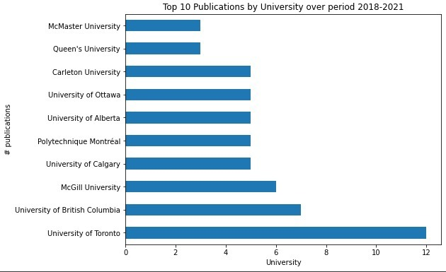

Figure . Top 10 publications by university

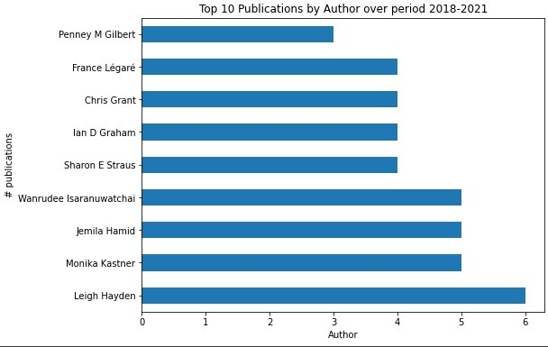

Figure . Top 10 publications by author

Table 2 describes the files related to the Academic paper scraping and cleaning process.

Table . Academic articles' data structure

|  |  |  |  |  |
| --- | --- | --- | --- | --- |
| **Academia** | | | | |
| **Original data** | **Cleaned Data [.csv]** | **Cleaning code [.jpynb]** | **Count** | **File Size [kb]** |
| cognit_papers | cognit_papers_unique | CognitPages_Scraping | 149 | 465 |
| **Total** | | | **149** | **465** |

## 2.3 News websites

The following list shows the news websites scrapped. They were selected amongst the most relevant Canadian news bulletins that showed no restriction against web scraping in their use policy. Also, some other important sources that produce content relevant for the study, such as Seniors Advocate BC were included.

* https://www.seniorsadvocatebc.ca/reports/
* https://www.seniorsadvocatebc.ca/news-media/
* http://seniorsfirstbc.ca/news/
* https://www.vancouverislandfreedaily.com/tag/seniors/
* https://www.nanaimobulletin.com/tag/seniors/
* https://www.mcmasteroptimalaging.org/
* https://news.bchousing.org/?q=seniors&search.x=0&search.y=0
* https://helpagecanada.ca/news/
* https://www.aarpethel.com/

After scraping the data, the group analyzed the most frequent bigrams, a combination of two words. By doing so, we were able to identify and remove unwanted comments that might affect the result of the models. In addition, for some analyses such as word cloud and sentiment analysis, punctuations, words containing numbers, brackets, and square brackets were removed.

These steps were conducted before the preprocessing of the text data to assure that our data are free of words unrelated to the topic, such as: Follow us on Facebook, Twitter, PressLike, email addresses, and others. Table 3 describes the file structure, the original dataset, the cleaned version, and which jupyter notebook file contains the code for the cleaning.

Table . News websites' data structure

|  |  |  |  |  |
| --- | --- | --- | --- | --- |
| **News** | | | | |
| **Original data** | **Cleaned Data [.csv]** | **Cleaning code [.jpynb]** | **Count** | **File Size [kb]** |
| seniors_advocate_bc_reports | seniors_advocate_bc_reports_cleaned | News_Cleaning_Seniors_Advocate_BC_Reports | 19 | 21 |
| seniors_advocate_bc_news | seniors_advocate_bc_news_cleaned | News_Cleaning_Seniors_Advocate_BC | 58 | 110 |
| seniors_first_bc_news | seniors_first_bc_news_cleaned | News_Cleaning_Seniors_First_BC | 39 | 34 |
| seniors_vancouverisland_seniors | seniors_vancouverisland_seniors_cleaned | News_Cleaning_VancouverIsland_Seniors | 173 | 247 |
| seniors_nanaimo_news | seniors_nanaimo_news_cleaned | News_Cleaning_Nanaimo_Seniors | 152 | 226 |
| mcmaster_blog_posts | mcmaster_blog_posts_cleaned | News_Cleaning_Mcmaster_Blog_Posts | 379 | 617 |
| bchousing_news | bchousing_news_cleaned | News_Cleaning_bchousing | 280 | 2368 |
| helpagecanada_news | helpage_news_cleaned | News_Cleaning_helpage | 70 | 249 |
| AARPEthel_articles | AARPEthel_articles_cleaned | Cleaning_AARP | 172 | 893 |
|  |  | **Total** | **1,315** | **4,765** |

The details on the steps used for removing the unwanted words can be found on the jupyter notebooks aforementioned.

# 3 Gathered data description

In total, we have:

* 58,716 tweets.
* 149 Academic articles.
* 1315 News publications.

However, after some detailed analysis, it was possible to identify duplicated article’s bodies and News Publications’ content thus they were removed, and the data were reduced to the following numbers:

* 58,716 tweets.
* 101 Academic articles
* 868 News publications.

# 4 Sentiment Analysis

The website lexalytics.com2 [10], states that Sentiment Analysis is the process of determining whether a piece of writing is positive, negative, or neutral. This process combines different machine learning techniques and Natural Language Processing (NLP) to assign scores to the topics, themes, and categories in a phrase or text.

Ronen Feldman3 defines sentiment analysis as: “the task of finding the opinions of authors about specific entities.” These entities can be documents, sentences, social media activity, reviews, etc. In addition, the author explains that these sentiments are valuable to companies to keep track of their products and services and how the users are reacting to them, in a positive or negative way, and take action accordingly.

For this project, the sentiments were extracted using the TextBlob python library and sentiment function. The function receives a string of text as input and returns the polarity score and the subjectivity.

According to TextBlob documentation [7]:

“The polarity score is a float within the range [-1.0, 1.0]. The subjectivity is a float within the range [0.0, 1.0] where 0.0 is very objective and 1.0 is very subjective.”

The process was conducted with the different sources separately, as described in the following paragraphs.

## 4.1 Twitter

On the Twitter scraped data, a combination of TextBlob and Transformers pipeline functions was used to calculate each tweet's sentiment score and classify them as with positive or negative connotations.

Since tweets have a limited number of characters and usually are smaller texts compared to the other 2 sources of data (News and Academic Articles), the presence of strong polarized words, either positive or negative, has a significant impact on the overall sentiment of the analyzed text.

Another investigation conducted was regarding the essence of Twitter social media. Twitter is known for being significantly related to the personal opinion of individuals complaining and creating trending topics to demonstrate dissatisfaction or, sometimes, praising a good service or product. Figure 3 shows the polarity distribution of the 57.139 tweets gathered to clarify the previous assumption.

Figure . Tweets' TextBlob polarity histogram

Contrary to expectations, it is possible to conclude that most tweets are close to 0, representing a neutral sentiment. The average polarity presented was 0.1261.

To improve the results and interpretability, we applied a transformers-based sentiment analysis. The Hugging Face Transformer library [11] provides a built-in pipeline for the task. Figure 4 shows the result of the alternative, improved sentiment analysis. It is now possible to observe well-defined groups of positive and negative tweets.

Figure . Tweets' Transformers polarity histogram

## 4.2 Academic articles

Academic Articles had their sentiment scores calculated and assigned alongside each observation. Then a detailed analysis of the negative sentiment articles was conducted. Their titles and scores are described in Table 4.

Table . Negative sentiment articles

|  |  |  |
| --- | --- | --- |
| **Title** | **Polarity** | **Length** |
| COVID-19 Physical Distancing and Post-Traumatic Stress Injury: Utilization of Digital Health and Remote Mental Health Services for Military, Veterans, and Public Safety Personnel (2020/21) | -0.0177 | 1976 |
| Extending the validation and reliability testing of SCREEN a nutrition risk screening tool for community-living seniors. (2020/21) | -0.0148 | 1974 |
| A collaborative evaluation of the Iiyuu Ahtaawin Miyupimaatisiiun Planning (IAMP) Initiative for Cree Health (2015/16-2018/19) | -0.0119 | 3424 |
| Canadian Frailty Network - Technology Evaluation in the Elderly Network (TVN) (2017/18-2020/21) | -0.0095 | 1602 |

Looking into the titles above, we can clearly identify words with negative polarity, such as Traumatic Stress Injury and nutrition risk. In addition, the length of the text is not short enough for us to conclude that the presence of some negative words would reduce the overall score. Thus, it means that, on average, the whole text had a negative connotation of words.

Although the negative values, the polarity scores were close to the 0-mark, neutral speech, which is the expected tone of speech on academic documents. The presented polarity average score for all academic articles was 0.1159.

## 4.3 News websites

For the scraped News, the polarity of the body contents was appended to the dictionary to its respective News texts. Additionally, the score is plotted on a timeline to verify how it spread among all the News gathered. The result is illustrated in Figure 5.

Figure . News Sentiment Analysis over years

The average polarity was 0.1507, and after 2019 some negative values started to appear.  The graph highlighted outliers and negative polarity News that were further investigated. The chart also revealed an increasing number of reports with spreader polarity in between over the years.

The News with the highest polarity contained the following content:

“June 15 is World Elder Abuse Awareness Day (WEAAD). Over 50 WEAAD events will take place across BC – Find Out More WEAR PURPLE to show your support!”

This outlier highlighted the possibility of having no detailed data regarding Elder-Wellbeing. However, after checking the news with the shortest texts (less than 300 words) the group decided to keep all of them since they were placeholders for reports containing important information for Elders, described in Table 5.

Table . Short texts analysis

|  |  |  |
| --- | --- | --- |
| **Body** | **Polarity** | **Length** |
| June 15 is World Elder Abuse Awareness Day (WEAAD) Over 50 WEAAD events will take place across BC –Find Out More WEAR PURPLE to show your support! | 0.500 | 147 |
| Seniors’ poverty in British Columbia is the highest rate in the country, based on latest data from Statistics Canada (2015).  Read more online –B.C. Seniors’ Poverty Report Card | 0.333 | 177 |
| Seniors First BC recently released its Annual Report for 2020-2021. The report provides updates and statistics about its programs during this period. To read the report, visit here. | 0.125 | 180 |
| Featuring: Legal Staff – Seniors First BC Victim Services Worker – Family Services of Greater Vancouver Public Guardian and Trustee of BC Designated Agency – Fraser Health Watch online | 0.175 | 186 |
| Our Seniors First BC COVID-19 resource list gives all the information for risks, the number of cases, symptoms, precautions and where to get help during this crisis. COVID-19 RESOURCES UPDATED May 15, 2020. | 0.250 | 207 |
| Find all the resources announced by the Province of BC regarding COVID-19 situation, it gives information on how to protect yourself, your family and your community and the steps to take if you suspect to have the virus. COVID-19 Provincial Support and Information. | 0 | 264 |
| Vaccine call centres for seniors open March 8, 2021. You can book a vaccine appointment for yourself or your spouse. It’s easy and safe to book over the phone. Our SAIL staff can assist as well. Call us at Call: 604-437-1940 or Toll Free: 1-866-437-1940 Click here for more details: | 0.367 | 282 |

The News with negative polarity was also further analyzed. Those content were related to grief, kill, death, scam, failure, illness, etc. Words with a strong negative sentiment reduced the overall score.

The websites were also analyzed separately to identify speech patterns and polarity of sentiment. However, on average, every news media presented a positive polarity.

Figure . Average polarity per News website

Furthermore, the websites were plotted in different timeline charts. For example, McMaster and Vancouver Island Seniors were the ones that presented news with negative sentiment, as illustrated in Figure 7 and Figure 8.

Figure . McMaster Blog sentiment score timeline

Figure . Vancouver Island Seniors sentiment score timeline

Again, it is possible to identify the increasing trend in the amount of news as the years passed.

# 5 Word cloud

A word cloud is a visual representation of word frequency. The more commonly the term appears within the text, the larger the word appears in the image generated. Word clouds are increasingly being employed as a simple tool to identify the focus of written material. Hence, we wanted to understand what the focus of our cleaned text looked like for the different sources.

Figure . Word Cloud for all Academic articles

Figure . Word Cloud for all News combined

Figure 9 and Figure 10 are the word clouds output we obtained from the clean contents of NEWS and Academic articles. It is possible to observe that the content is majorly focused on support for the elderly, Projects related to the elderly, inclusion, home, affordability, housing aspects, health, community, etc. The size of the words signifies the frequency in which the topic was discussed. (Colors in the picture are just for beautification. The color does not indicate anything.)

By combining the word cloud from multiple sources with Topic Modelling and Sentiment analysis, we created a dashboard that clearly illustrated the concerns for elders per period, described in detail in section 7.

# 6 Topic Modeling

Before building a model based on the text scrapped from twitter, news and academic articles, a preprocessing task was conducted to eliminate “stop words” and apply lemmatization and stemming on the corpus.

When analyzing text with NLP processes, “stop words” are often eliminated. These words include articles, some connectors, and everyday words/expressions.

Stemming is a popular way to minimize the vocabulary size in NLP tasks as this process converts words with the same “stem” or root to a single word. Stemming can be based on rules or based on context. Due to the amount of data and the length of the text – especially in the case of Twitter – in this project, rules-based treatment was selected.

Lemmatization usually refers to doing things properly using a vocabulary and morphological analysis of words, usually aiming to remove inflectional endings only and return the base or dictionary form of a word, known as the “lemma” [8].

To perform the semantic similarity detection and calculate the most relevant topics in the project’s corpus, several options were considered, but BERT was selected per the results obtained.

## 6.1 BERT topic modeling

An acronym for Bidirectional Encoder Representations from Transformers, BERT is a language representation model. A pre-trained BERT model can be fine-tuned with just one additional output layer to create state-of-the-art models for a wide range of tasks, such as question answering and language inference, without substantial task-specific architecture modifications [3].

In essence, using a pre-trained language model allows us to get closer to the message intent of each text body. The representation of each tweet, academic article, or news page can be embedded in a vector space that captures the semantics and sentence structures of the text.

The model created using BERT provided a range of distinct topics, relevant and irrelevant for our research.

Table . Top ten topics for Twitter corpus

|  |  |  |
| --- | --- | --- |
| **Topic** | **Count** | **Name** |
| -1 | 30633 | -1_and_to_the_of |
| 0 | 1032 | 0_mens_senior_championship_team |
| 1 | 655 | 1_citizen_senior_seniors_citizens |
| 2 | 405 | 2_housing_affordable_rental_units |
| 3 | 388 | 3_pharmacare_drugs_prescriptions_drug |
| 4 | 350 | 4_dog_cat_cats_dogs |
| 5 | 344 | 5_trudeau_trudeaus_justin_harper |
| 6 | 325 | 6_christmas_stockingstuffersforseniors_gifts_s... |
| 7 | 303 | 7_music_album_songs_song |
| 8 | 301 | 8_abuse_awareness_elder_elderabuse |

Table 6 shows the top ten topics for Twitter retrieved from BERT built-in architecture in Huggin Face Transformers library [11]. Topic enumerated as -1 contains the observations not included in the other groups.

Table . Topics for Academic articles corpus

|  |  |  |
| --- | --- | --- |
| **Topic** | **Count** | **Name** |
| -1 | 49 | -1_indigen_communiti_research_health |
| 0 | 28 | 0_communiti_research_indigen_elder |
| 1 | 24 | 1_care_patient_hospit_studi |

Table . Top ten topics for News corpus

|  |  |  |
| --- | --- | --- |
| **Topic** | **Count** | **Name** |
| 0 | 303 | 0_hous_home_afford_peopl |
| -1 | 208 | -1_care_health_senior_older |
| 1 | 151 | 1_year_like_hair_love |
| 2 | 69 | 2_blood_diet_diabet_heart |
| 3 | 62 | 3_senior_care_report_advoc |
| 4 | 58 | 4_older_social_adult_care |
| 5 | 39 | 5_vaccin_covid_outbreak_staff |
| 6 | 35 | 6_walk_exercis_fall_speed |
| 7 | 28 | 7_cancer_smoke_quit_screen |
| 8 | 26 | 8_pain_exercis_pillow_treatment |

Figure 11 illustrate the topics captured from our dataset. In the case of Twitter, topic 2 is built around the “housing”, “affordable”, “rental”, “units”, and “rent”, thus is easy to see this subset of data is about the housing conditions affecting Elders. On the Other hand, the topic 0 contains the words “men”, “senior”, “championship”, “team”, “game” which might mean that the subset of tweets is related to some sports competition, hence it is off-topic and is not related to our Project’s topic.

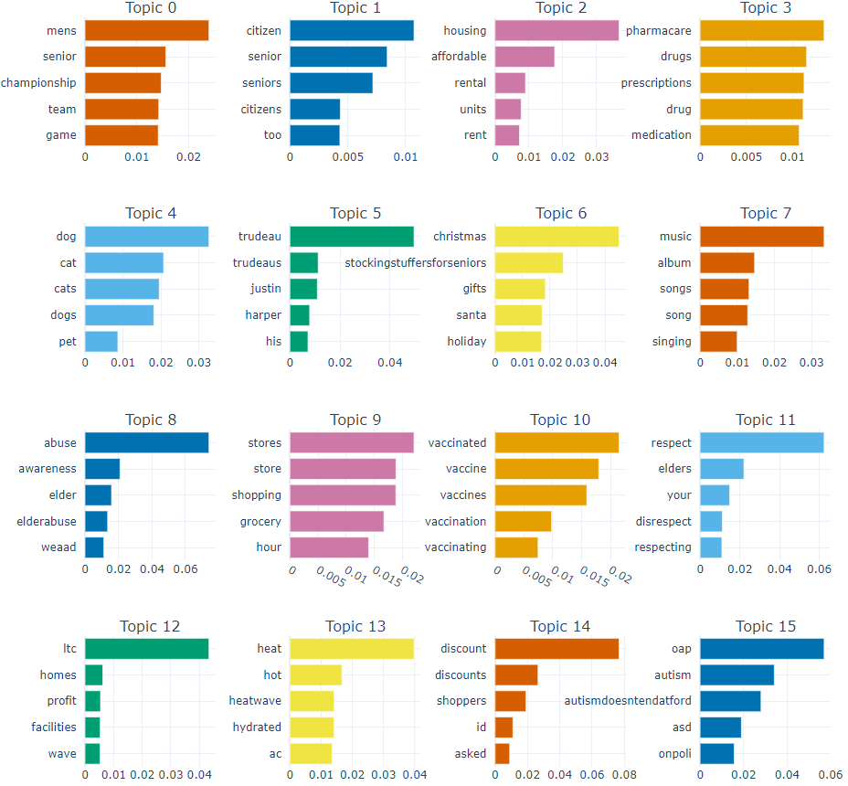

Figure . Tweets topic word scores

Figure . News topic word scores

In terms of the topics from the news media analysis, Figure 12 shows that, for instance, topic 0 is built around the concept of “care”, “health”, “senior”, “older”, and “help”, making clear that those news articles are related to the health care.

## 6.2 Topics refinement

To refine the results from topic modeling with BERT, we adopted an approach that could consider as input the aspects relevant to our research study. Therefore, the topics described in the previous section were aggregated by similarity to 19 parent topics: Covid, Health, House, Homecare, Money, Volunteer, Safety, Abuse, Physical Activity, Social Activity, First Nations, Schooling, Environment, Autonomy, Freedom, Climate, Temperature, Vaccine, and Grocery. The final results will be explored in the following sections.

# 7 Dashboard and results

By combining the techniques explained in the previous section, the group created a Tableau Dashboard capable of capturing the sentiment and the frequency of the topics on all the media sources studied in a monthly manner. However, since the academic articles presented only two major topics on its corpus, they were left aside from the dashboard analysis.

 The interactive capabilities of the tool assisted in the discovery of patterns and in featuring the major concerns faced by the elderly society. Figure 13 shows the structure of the dashboard, and Figure 14 illustrates the final version.

Figure . Dashboard structure

Figure . Tableau dashboard

In this case, the colors represent the polarity of the sentiments, where red means negative, and green, positive.

It is possible to observe the difference variation between tweets and news bulletins as expected News websites presented smaller variations in polarity, while Twitter showed great ups and downs during the period.

By analyzing that variation, it was possible to investigate what were the topics mentioned on those periods of major positivity and negativity and contextualize them with the world events. Some were described in the following images.

Figure . Periods with greater and lesser polarity

The next group of images represents the topics present in the Highest polarity periods.

Figure . November 2018 Word cloud snapshot

Figure . December 2018 Word cloud snapshot

Figure . November 2019 Word cloud snapshot

Figure . November 2021 Word cloud snapshot

Figure . December 2021 snapshot

November and December had the social activity as the main topic with extreme positive polarity. This is due to the festivities and holidays, a period when there is a lot of social interaction when families gather around and share good times. When intergenerational relationships are at their peak, seniors and those who advocate for them say positive things.

The following images represent some of the most negative sentiments of the period.

Figure . March 2020 Word cloud snapshot

Figure . April 2020 snapshot

These months were when the first wave of COVID-19 happened.  As we can see, the most mentioned topic on March 2020 was not the Pandemic itself but a concern related to groceries. Once the lockdown was in place, how elders would have access to food and essential products was a major discussion.

A month later, the COVID-19 took the lead on most discussed problems among the senior society, and grocery became the second most frequent topic, however, with a more neutral (yellow color) sentiment.

Figure . August 2020 Word cloud snapshot

Figure . September 2021 snapshot

Both August 2020, and September 2021, also presented the Covid vaccine and COVID as a big concern, along with other topics. Expected results during the two pandemic years.

Another problem easy to identify using the dashboard was those related to climate change and temperature. For example, the following image exhibits the concern related to the temperatures during the summer of July 2020.

Figure . July 2020 snapshot

Although some data are easy to contextualize, others are not. For example, the following three images represent other negative polarity periods when the sentiment was spread around different topics.

Figure . August 2019 Word cloud snapshot

In August 2019, the discussions were about money, health, social activity, and freedom, however, it’s not clear what major event happened during that period.

There were other scenarios with low sentiments where the leading cause was not clearly defined. For those periods, a more detailed contextualization is required. Again, crosschecking News and other information sources would help identify what happened.

# 8 Recommendations and next steps

To continue this analysis, we recommend combining sentiment analysis, word cloud, and topic modeling techniques to further contextualize the topics highlighted in the dashboard. In addition, gathering more Academia material would be valuable for comparison with the other sources and to improve Academia’s topic modeling results. Another possible approach is identifying government and other institutions' measures and responses to the featured problems and how they increased overall sentiment.

Furthermore, classify the Tweets according to related and non-related to elderly-wellbeing to even increase the perception among the target audience. For this specific process, we recommend some labeling techniques with clustering analysis over the 57 thousand tweets, using K-means to identify the relevant observations and propagate the label around the clusters defined. This is an effective, yet faster labeling method tested on a different dataset and resulted in meaningful accuracy increases over classification models. The details are provided in the paper Clustering for Semi-Supervised Learning on Disasters Tweets file in the submission folder.

# 9 Acknowledgement

The team would like to wholeheartedly thank Jessica Blaquiere and Karan Bhardwaj for their support and our instructor Quynh Monica Nguyen, for the opportunity to work on a transformative project.

This work received invaluable advice and domain-knowledge input from Colleen Fraser and Bonnie Milne.

# REFERENCES

[1] Bird, Steven, Ewan Klein, and Edward Loper. *Natural Language Processing with Python*. *NLTK*. O'Reilly Media, 2016. https://www.nltk.org/book/.

[2] Cudmore, Cora-Lee. “2018 World Elder Abuse Awareness Day.” Seniors First BC, June 13, 2018. https://seniorsfirstbc.ca/news/2018-world-elder-abuse-awareness-day/.

[3] Devlin, Jacob, Ming-Wei Chang, Kenton Lee, and Kristina Toutanova. “Bert: Pre-Training of Deep Bidirectional Transformers for Language Understanding.” arXiv.org, May 24, 2019. https://arxiv.org/abs/1810.04805.

[4] Feldman, Ronen. “Techniques and Applications for Sentiment Analysis.” ACM, April 1, 2013. https://cacm.acm.org/magazines/2013/4/162501-techniques-and-applications-for-sentiment-analysis/fulltext.

[5] “Gensim: Topic Modelling for Humans.” Topics and Transformations - gensim, December 22, 2021. https://radimrehurek.com/gensim/auto_examples/core/run_topics_and_transformations.html#sphx-glr-auto-examples-core-run-topics-and-transformations-py.

[6] Grootendorst, Maarten P. “Bertopic.” BERTopic. Accessed April 18, 2022. https://maartengr.github.io/BERTopic/index.html.

[7] Loria, Steven. “Tutorial: Quickstart.” Tutorial: Quickstart - TextBlob 0.16.0 documentation, 2020. https://textblob.readthedocs.io/en/dev/quickstart.html.

[8] Manning, Christopher – Raghavan, Prabhakar – Schütze, Hinrich. “Introduction to Information Retrieval”, Cambridge University Press, 2008. https://nlp.stanford.edu/IR-book/html/htmledition/tf-idf-weighting-1.html

[9] Ruggeri, K., Garcia-Garzon, E., Maguire, Á., Matz, S. and Huppert, F.A. (2020), “Well-being is more than happiness and life satisfaction: A multidimensional analysis of 21 countries”, Health and Quality of Life Outcomes, BioMed Central Ltd., Vol. 18 No. 1, pp. 1–16.

[10] “Sentiment Analysis Explained”. 2022. Lexalytics. https://www.lexalytics.com/technology/sentiment-analysis

[11] “Transformers”. Accessed April 18, 2022. https://huggingface.co/docs/transformers/index.

[12] “Twitter API Documentation | Docs | Twitter Developer Platform.” Twitter. Twitter. Accessed April 18, 2022. https://developer.twitter.com/en/docs/twitter-api.

# APPENDIX A

|  |  |  |
| --- | --- | --- |
| **Primary Key Words** | **Synonyms - Secondary Key Words** | **Antonyms** |
| **Learning** | Scholarly knowledge | Unlearn |
| **Learning** | Scholarship | Neglect |
| **Learning** | Erudition | Ignorance |
| **Learning** | Schooling | Lack of knowledge |
| **Learning** | Study | Noncognitive process |
| **Learning** | Acquisition | Loss |
| **Learning** | Information | Disinterest |
| **Learning** | Wisdom | Stupidity |
| **Learning** | Educated | Uneducated |
| **Learning** | Cognitive process | Learning disability |
| **Social Support** | Human society | Lonesomeness |
| **Social Support** | Communities | Isolations |
| **Social Support** | Societal | Outcast |
| **Social Support** | Sociable | Unsocial |
| **Social Support** | Ethnic | Introvert |
| **Social Support** | Ethnical | Lonely |
| **Social Support** | Cultural | Segregate |
| **Social Support** | Sociality | Noncultural |
| **Social Support** | Friendly | Social exclusion |
| **Social Support** | Interpersonal | Unfriendly |
| **Social Support** | Friendly companion | Antisocial |
| **Respect** | Admiration | Disapproval |
| **Respect** | Deference | Defiance |
| **Respect** | Respectfulness | Disrespect |
| **Respect** | Courtesy | Impoliteness |
| **Respect** | Obedience | Rudeness |
| **Respect** | Ovation | Misbehavior |
| **Respect** | Veneration | Detest |
| **Respect** | Worship | Despise |
| **Respect** | Obeisance | Inconsideration |
| **Respect** | Esteem | Bad behavior |
| **Respect** | Regard | Casual attitude |
| **Respect** | Value | Scorn |
| **Respect** | Prize | Disdain |
| **Respect** | Appreciation | Disgust |
| **Respect** | Honor | Hate |
| **Respect** | Consideration | Dislike |
| **Respect** | Curteous | Antipathy |
| **Respect** | Behavior | Misconduct |
| **Freedom** | From duty | Captivity |
| **Freedom** | Free | Limitation |
| **Freedom** | Liberty | Restraint |
| **Freedom** | Unrestraint | Restriction |
| **Freedom** | Opportunity | Suppression |
| **Freedom** | Power | Reserve |
| **Freedom** | Privilege | Dependence |
| **Freedom** | Right | Constraint |
| **Freedom** | Exemption | Permanence |
| **Freedom** | Flexibility | Immovableness |
| **Freedom** | Immunity | Vulnerability |
| **Freedom** | Mobility | Ban |
| **Freedom** | Being free | Disallowance |
| **Helping Strangers** | Amend | Discourage |
| **Helping Strangers** | Assist | Hurt |
| **Helping Strangers** | Better | Harm |
| **Helping Strangers** | Assistance | Frustrate |
| **Helping Strangers** | Improve | Discouragement |
| **Helping Strangers** | Facilitate | Prevent |
| **Helping Strangers** | Ameliorate | Complicate |
| **Helping Strangers** | Encourage | Delay |
| **Helping Strangers** | Boost | Block |
| **Helping Strangers** | Fulfillment | Inhibit |
| **Volunteering** | Without payment | Oblige |
| **Volunteering** | Unpaid | Paid labor |
| **Volunteering** | Offer | Gainful employment |
| **Volunteering** | Informal | Gainful occupation |
| **Volunteering** | Voluntarily | Wage employment |
| **Life Satisfaction** | Payment | Frustration |
| **Life Satisfaction** | Atonement | Discontent |
| **Life Satisfaction** | Change | Disappointment |
| **Life Satisfaction** | Compensation | Dissatisfaction |
| **Life Satisfaction** | Contentment | Displeasure |
| **Life Satisfaction** | Desire | Distaste |
| **Positive mood** | Affirmation | Negativity |
| **Positive mood** | Encouraging | Negativism |
| **Positive mood** | Positivism | Despair |
| **Positive mood** | Favorableness | Lack of hope |
| **Wellbeing** | Wellness | Unwell |
| **Wellbeing** | Healthy | Unhealthy |
| **Wellbeing** | Successfulness | Diseased |
| **Wellbeing** | Social Welfare | Detrimental |
| **Elder** | Senior |  |
| **Elder** | Seniority |  |
| **Elder** | Elderly |  |
| **Elder** | Aged |  |
| **Elder** | Aging |  |
| **Elder** | Older |  |
| **Elder** | Fourth Year |  |
| **Elder** | Old |  |
| **Elder** | Older Adults |  |
| **Elder** | Aged |  |
| **Elder** | Geriatric |  |
| **Elder** | Aging |  |
| **Personal growth** | Personal Development | Degradation of the individual |
| **Personal growth** | Development Of The Individual | Decay of personality |
| **Personal growth** | Self-Fulfilment | Personal decline |
| **Personal growth** | Individual Development | Degradation of person |
| **Relatedness** | Relationship | Separation |
| **Relatedness** | Kinship | Conflict |
| **Relatedness** | Affinity | Dissimilarity |
| **Relatedness** | Association | Isolation |
| **Relatedness** | Connection | Division |
| **Relatedness** | Connectivity | Solitude |
| **Positive relations** | Good Relations | Distant relationship |
| **Positive relations** | Beneficial Relations | Hostile relationship |
| **Positive relations** | Certain People | Unhealthy relationship |
| **Positive relations** | Constructive Interaction | Unfriendly relationship |
| **Social Acceptance** | Social Recognition | Disagreement |
| **Social Acceptance** | Public Acceptance | Self-isolation |
| **Social Acceptance** | Community | Social distancing |
| **Social Acceptance** | Collective Acceptance |  |
| **Social Acceptance** | Community Acceptance |  |
| **Social Integration** | Social Inclusion |  |
| **Social Integration** | Social Insertion |  |
| **Social Integration** | Social Inclusiveness |  |
| **Social Integration** | Social Reinsertion |  |
| **Social Integration** | Society Reintegration |  |
| **Self-efficacy** | Self-Motivation | Hesitation |
| **Self-efficacy** | Belief In One’s Ability To Succeed | Fail |
| **Self-efficacy** | Personal Efficacy | Procrastination |
| **Competence** | Ability | Inability |
| **Competence** | Capability | Incapacity |
| **Competence** | Proficiency | Incompetence |
| **Competence** | Skill | Ineptitude |
| **Competence** | Expertise | Impotence |
| **Competence** | Functionality | Uselessness |
| **Competence** | Capacity | Inadequacy |
| **Competence** | Talent | Unfitness |
| **Competence** | Aptitude | Inefficiency |
| **Autonomy** | Freedom | Confinement |
| **Autonomy** | Independence | Dependency |
| **Autonomy** | Self-Sufficiency | Forbidding |
| **Autonomy** | Free Will | Prohibition |
| **Autonomy** | Empowerment | Denial |
| **Autonomy** | Independent | Rejection |
| **Social contribution** | Social Welfare Benefit |  |
| **Social contribution** | Social Allowance |  |
| **Social contribution** | Welfare Benefit |  |
| **Environmental mastery** |  |  |
| **Perceived development of one's potential** |  |  |
| **Money** |  |  |
| **Happiness** |  |  |
| **Family** |  |  |
| **Content (feeling)** |  |  |
| **Luxury** |  |  |
| **Social Status** |  |  |
| **Job** |  |  |
| **Intergenerational contact** |  |  |